**CHAPTER IV**

**RESULTS AND DISCUSSION**

The main purpose of this chapter is to provide the presentation, analysis and interpretation of data that has been categorized in accordance with the sequence of questions enumerated in the first chapter. All of the data collected from the evaluators were presented in tabular form with corresponding discussion and explanation of the findings obtained.

**Part I. Development of VirtualShrine: An interactive museum website for Casa Real Shrine**

Over time, museums continue to be forgotten by people, so some of them do not know about the importance of history. One of them is the Casa Real Shrine of Malolos. Because of the continuous advancement of modern technology, some of what can be seen in the museum can also be seen on the internet, the proponents have looked for a way so they introduced the “Virtual Shrine” a website that people can use to see what’s inside of the Casa Real Shrine and can book for their visit via online booking.

* 1. **Online Booking Reservation**

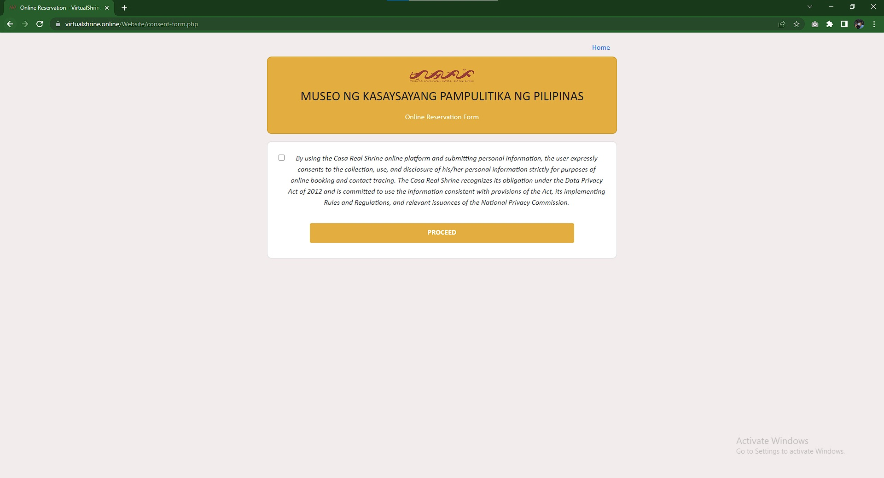

**Figure 54. Booking Consent Form**

Figure 54 displays the Booking Consent Form page. This page contains a statement regarding the collection of the visitor’s booking information. This page is required because the visitor will have to provide their personal information. By checking the consent for checkbox, the visitor consents the collection of their information.

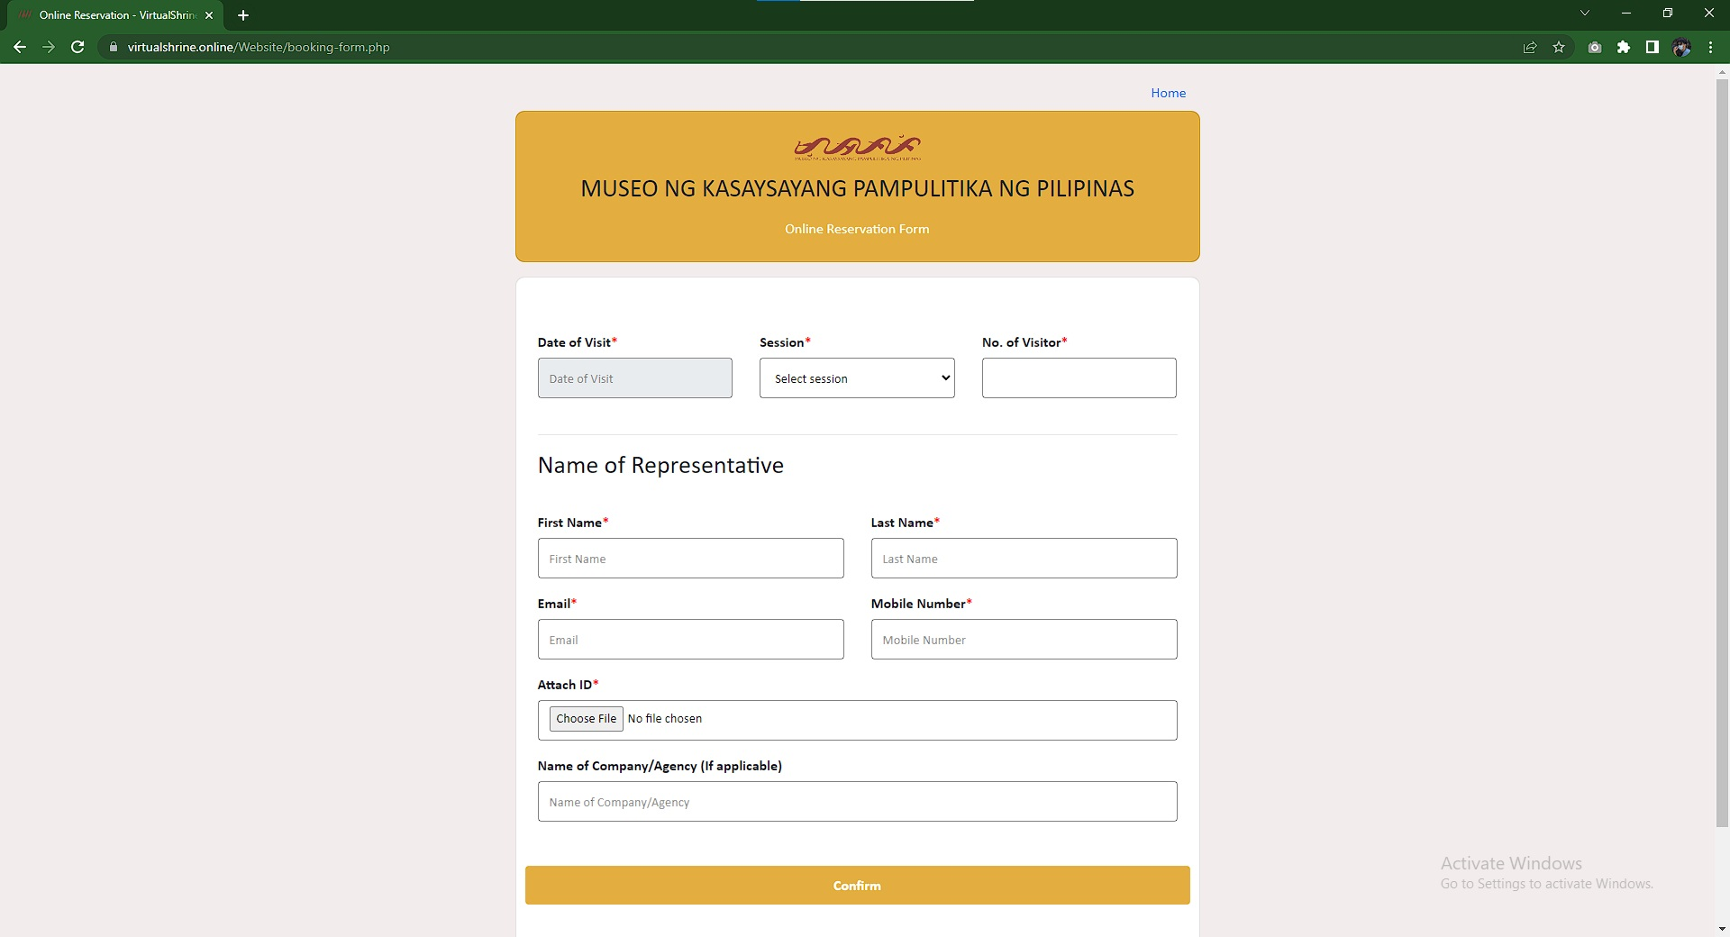

**Figure 55. Booking Form**

This figure 55 displays the Booking form where the visitor could fill out all of the required fields such as Date of Visit, Session, Number of Visitors, First Name, Last Name, Email, Mobile Number, and attach a screenshot of their valid ID to confirm the user's booking for the date.

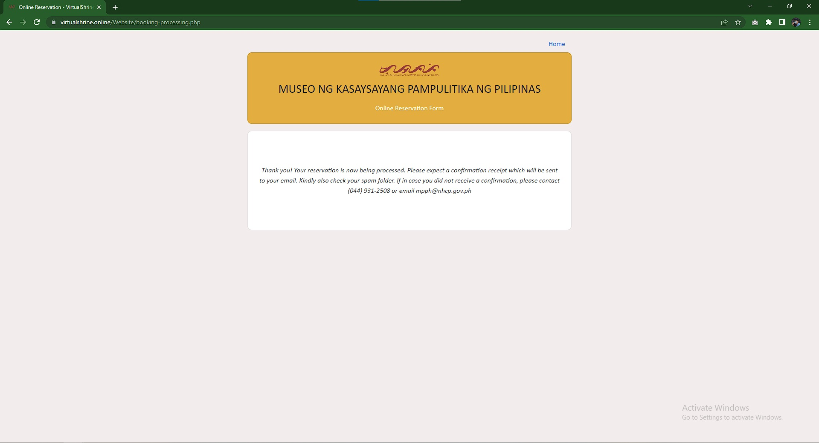

**Figure 56. Booking Submitted Confirmation Page**

Figure 56 displays the confirmation page that the visitor’s booking is submitted successfully and will be reviewed by the administrator if all the details that the visitor provided are valid.

**1.3 Virtual Museum Tour**

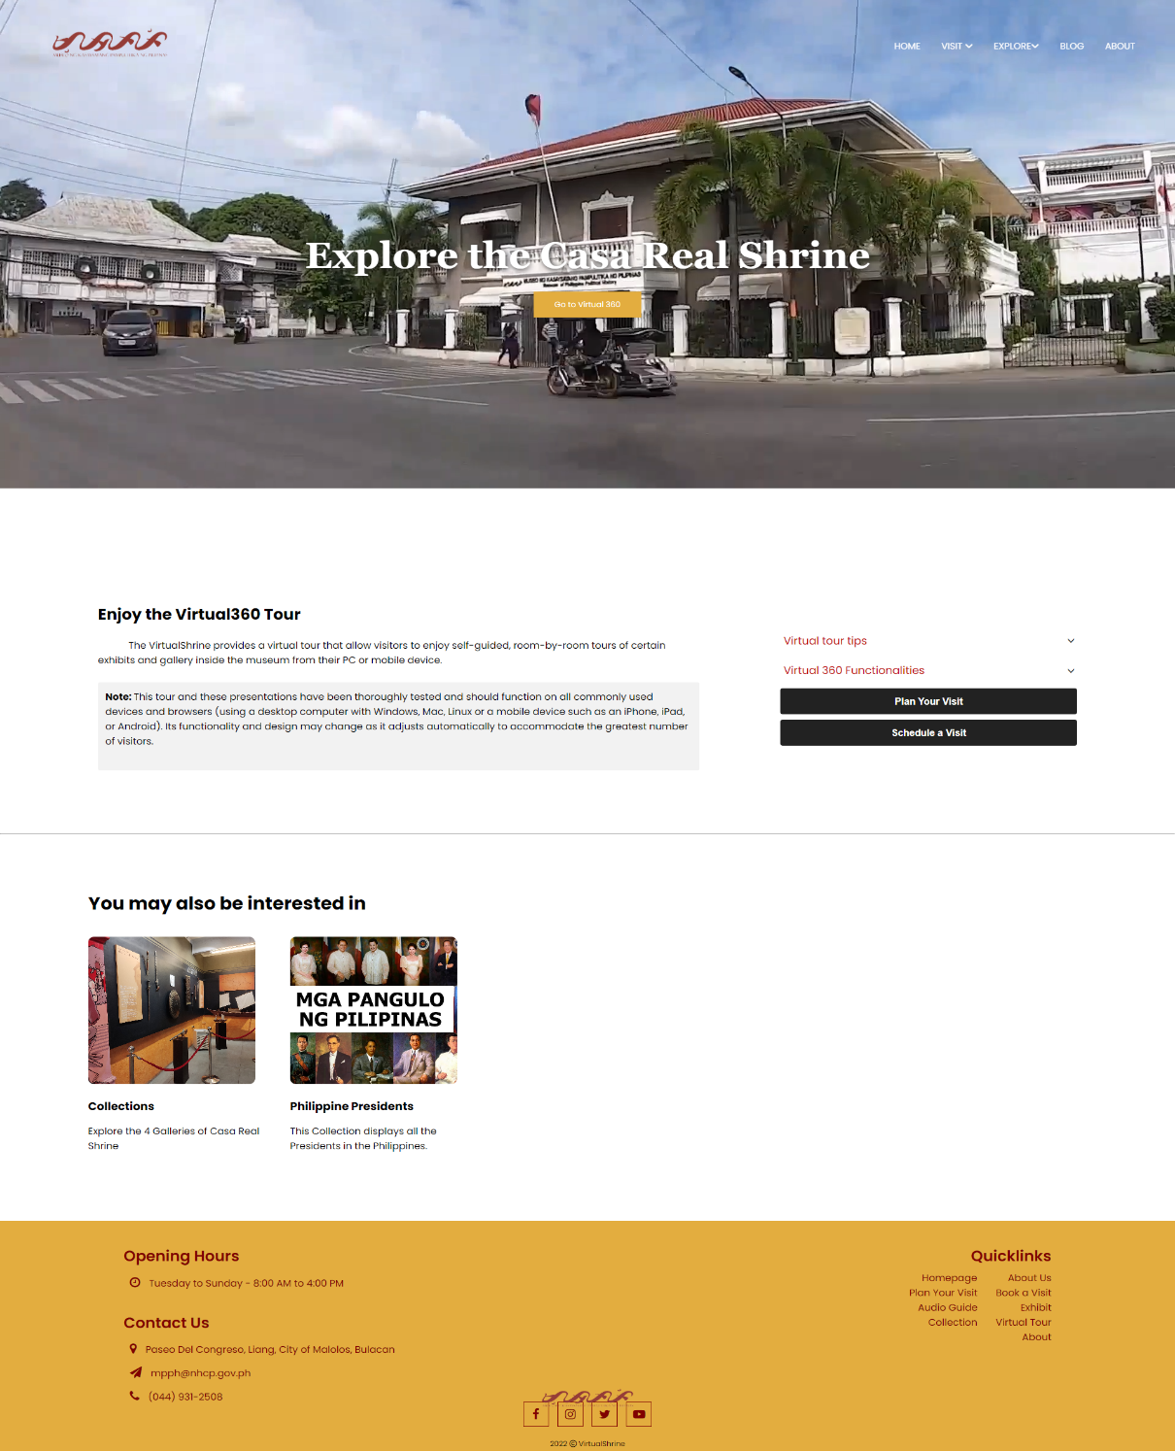

**Figure 57: Access to the Virtual Tour Page**

One of the main features of the website is the Virtual 360, visitors can interact in the museum virtually meaning if they want to visit the museum, they can check it first on the website using this 360 features. Figure 57 displays the page before accessing the main features of the website which are indicated in the next figures.

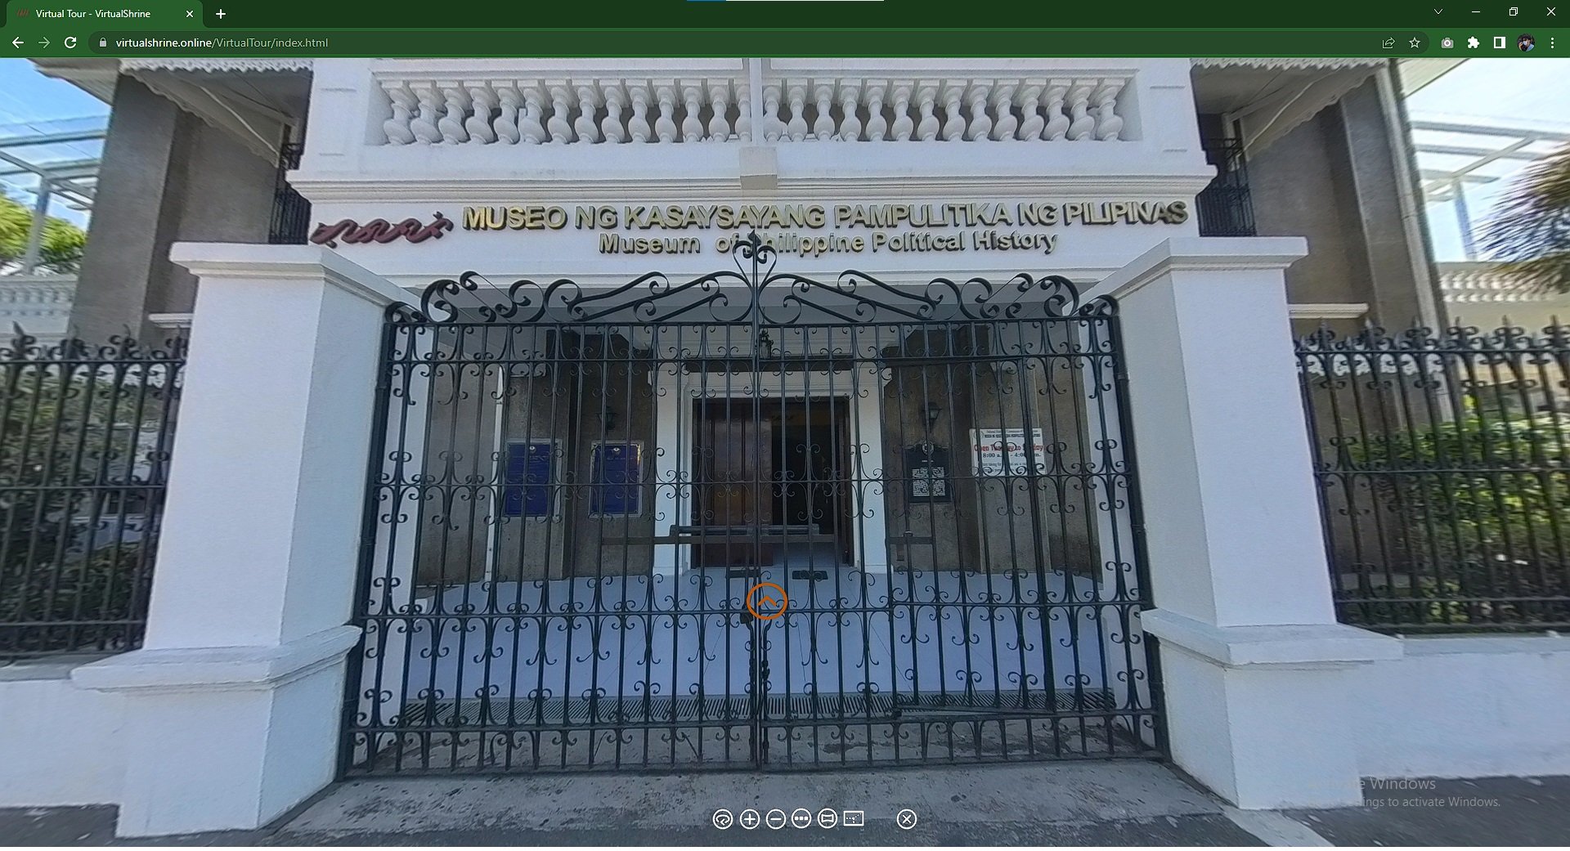

**Figure 58. Casa Real Shrine Virtual 360**

Figure 58 displays the landing page when the user opens the virtual tour. This page reflects the main gate of the Casa Real Shrine, the yellow Door icon is the hotspot for the user to access figure 58 or the lobby of the museum. At the bottom part of, the screen displays the controller for the virtual tour. This helps the user to familiarize themselves with the virtual 360 and navigate it easily. This controller includes Zoom In, Zoom Out, Auto Rotate, Show User Date, Thumbnail Menu, enter to full screen, and exit to virtual tour.

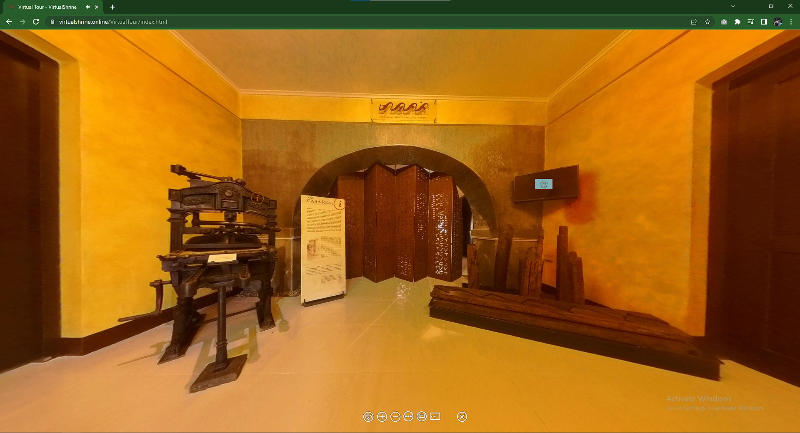

**Figure 59. Casa Real Shrine Lobby Virtual 360**

Figure 59 displays the first room of the museum after entering the building. The Visitor can swipe from left and right to view the surroundings of the room and to interact with other hotspots they can use for other information of the museum. The hotspot where the visitor can use to interact with the display in the museum. If the visitor presses the hotspot, the system will display a pop-up with the definition of the display.

**1.4 Gallery Collections**

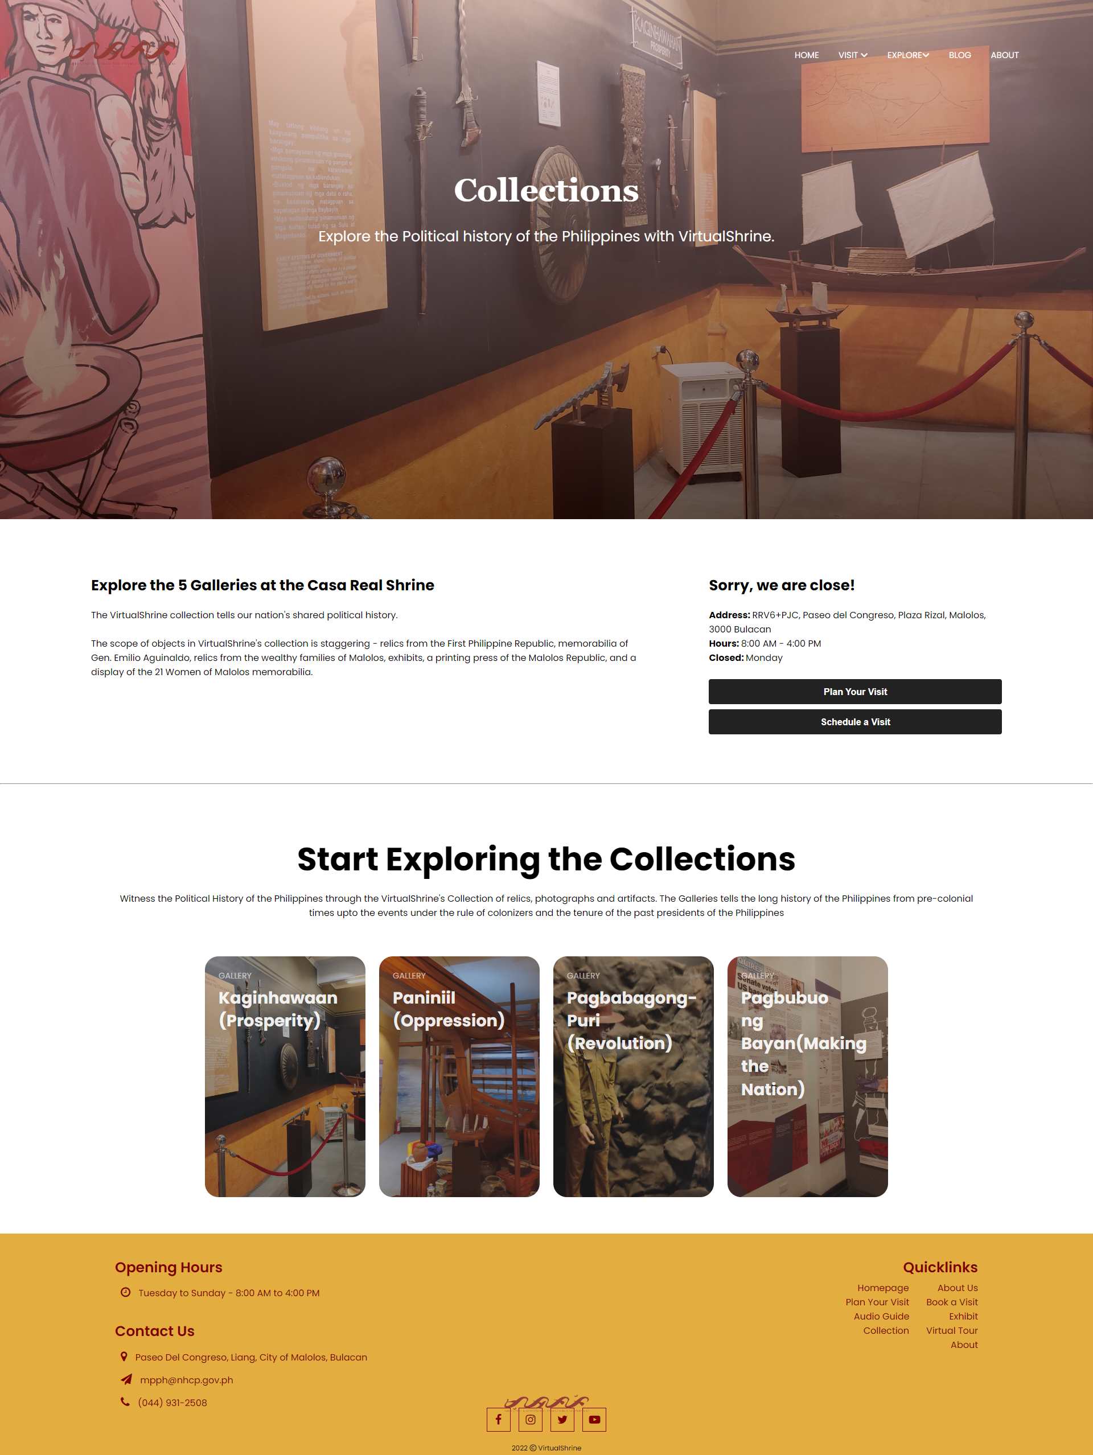

**Figure 60. Galleries**

Figure 60 displays the 4 galleries in the museum. Every cards lead to different rooms in the museum like Kaginhawaan(Prosperity), Paniniil(Oppression), Pagbabagong-puri(Revolution), Pagbuo ng bayan(Making the nation).

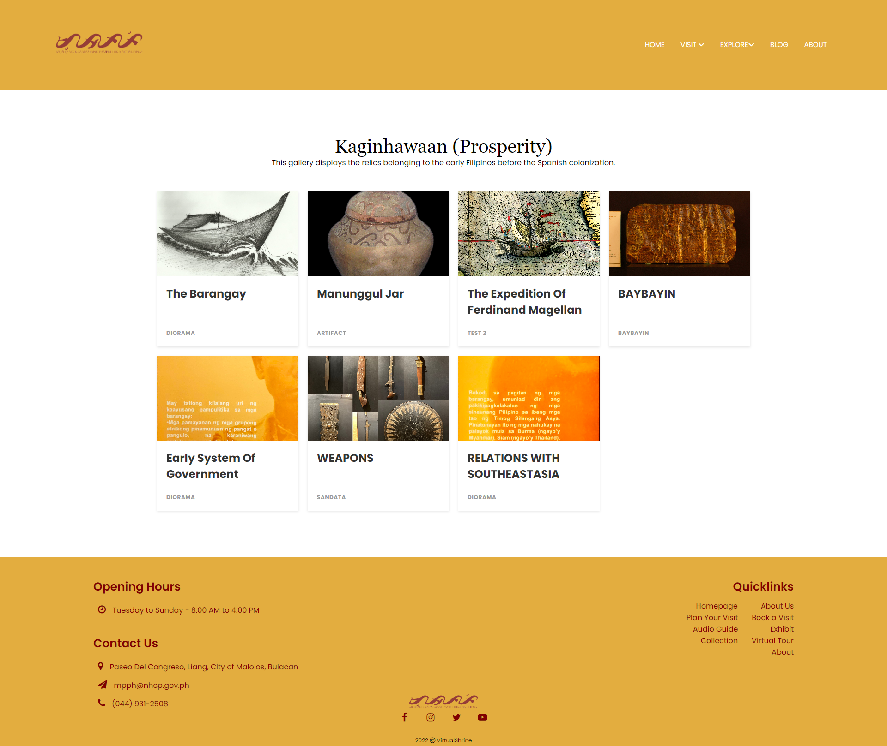

**Figure 61. Galleries Collections**

Figure 61 displays the gallery Collections and the different displays found inside the gallery.

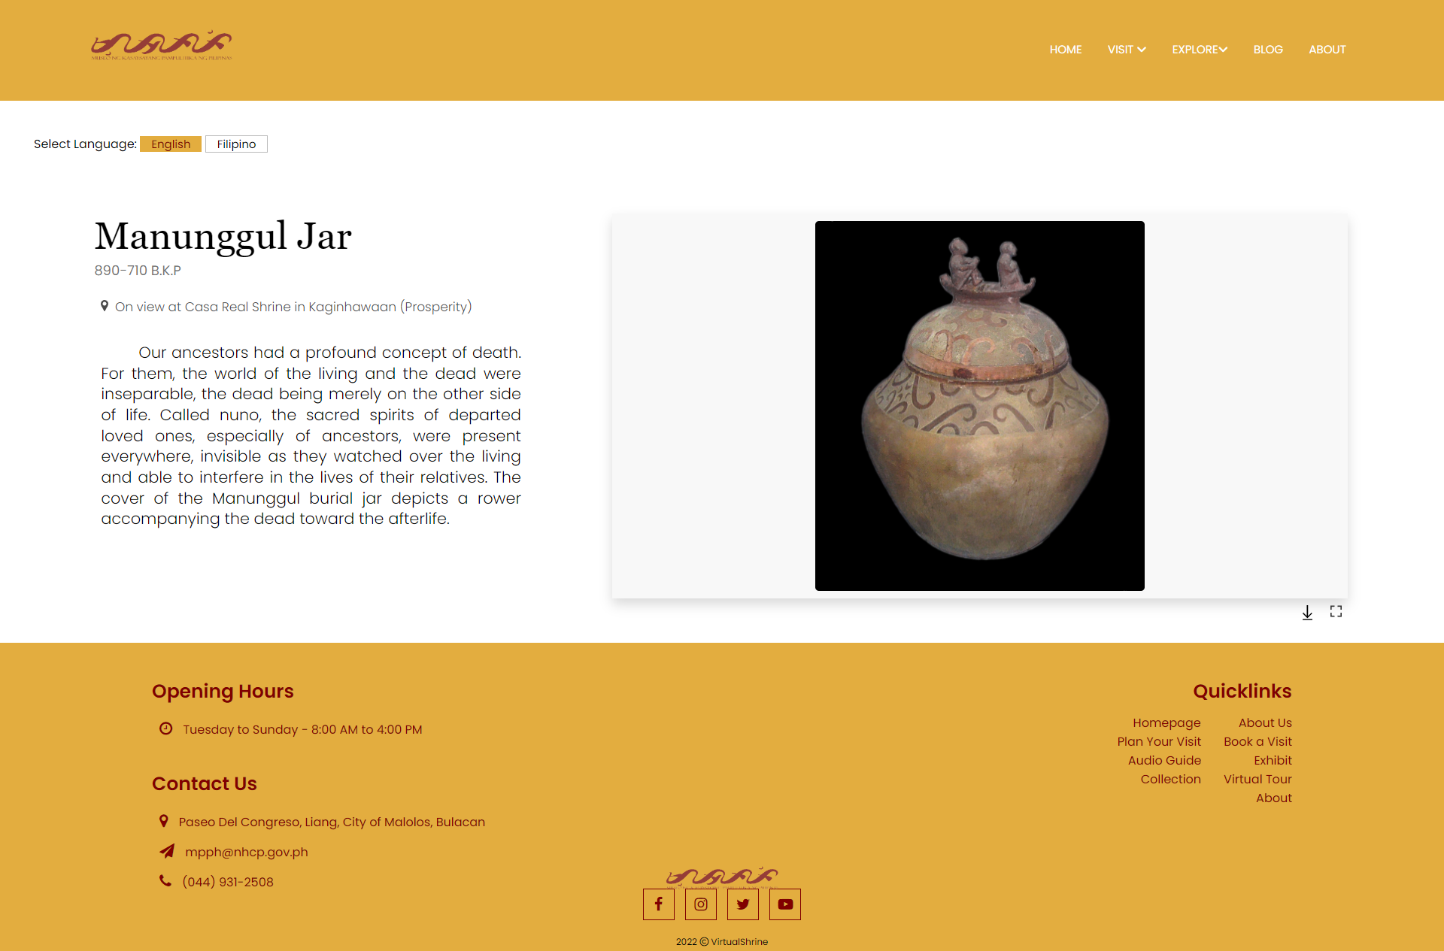

**Figure 62. Display Description**

Figure 62 display information about the display. Visitors can also download and print the artifact picture and description but with website mark to avoid plagiarism and copyrights.

**1.6 User assisting features**

**Figure 63. Plan Your Visit Page**

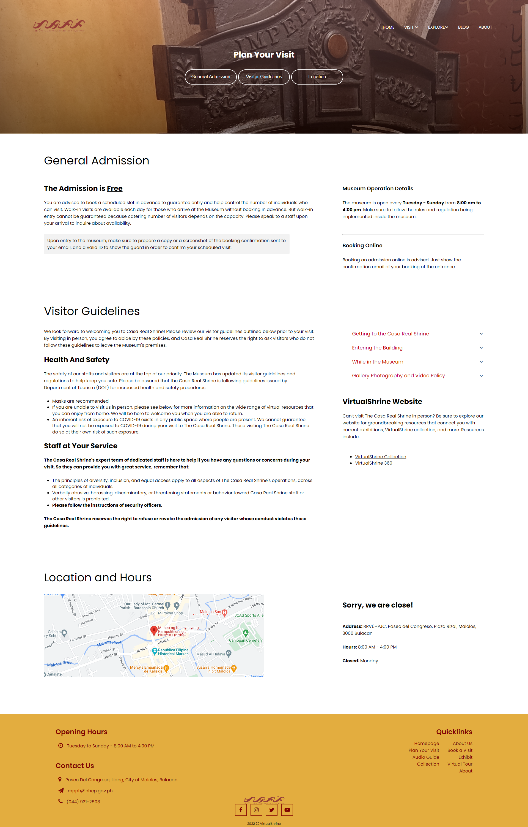

Figure 63 displays the general information regarding the operation of Casa Real Shrine such as the operation time and day, and Health and Safety Guidelines that is being implemented in the museum.

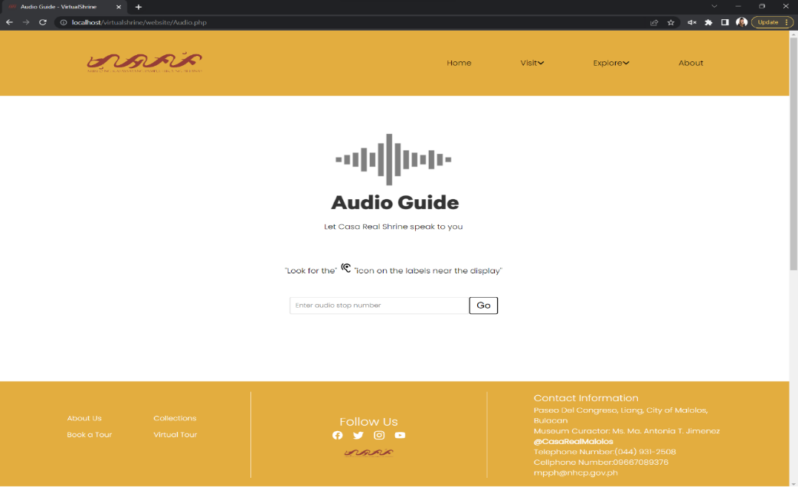

**Figure 64. Audio Guide**

Figure 64 displays the audio guide page. To access the audio guides for each display, the user will have to input the audio stop number on the textbox provided .

**Part II. To design and develop a Management System**

In order to better manage the website content and allow admins to upload and modify the contents seen on the website, a Management System was developed.

**2.1 Manage User Admins**

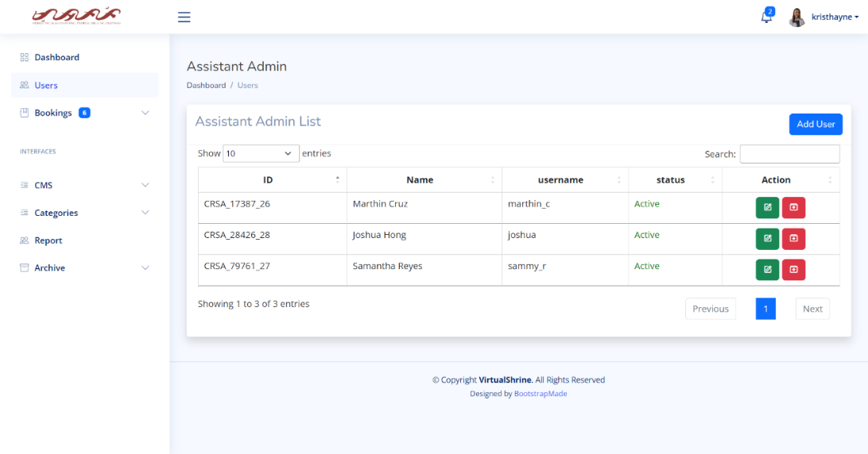

**Figure 65. User Management**

Figure 65 shows the user management panel. This is where the super admin will be able to view all the assistant admins. This page displays a table containing the user information ID, Name, Username, and their Status. The action buttons, edit and archive is also available.

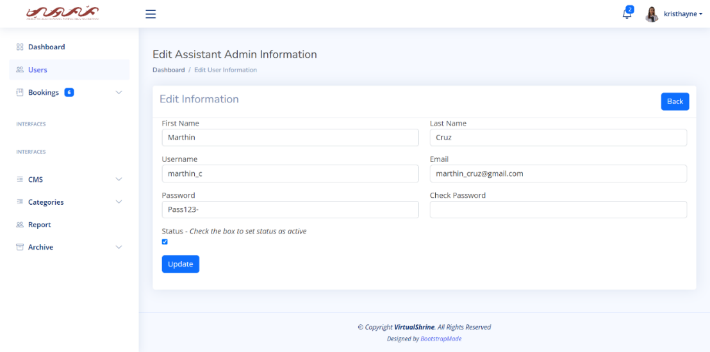

**Figure 66. Edit User Information**

Figure 66 displays the Edit User Information form. This is the form where the Super Admin can make modifications or changes to the user information. The admin can make any alterations they wish to the user information by simply changing the value in the text area.

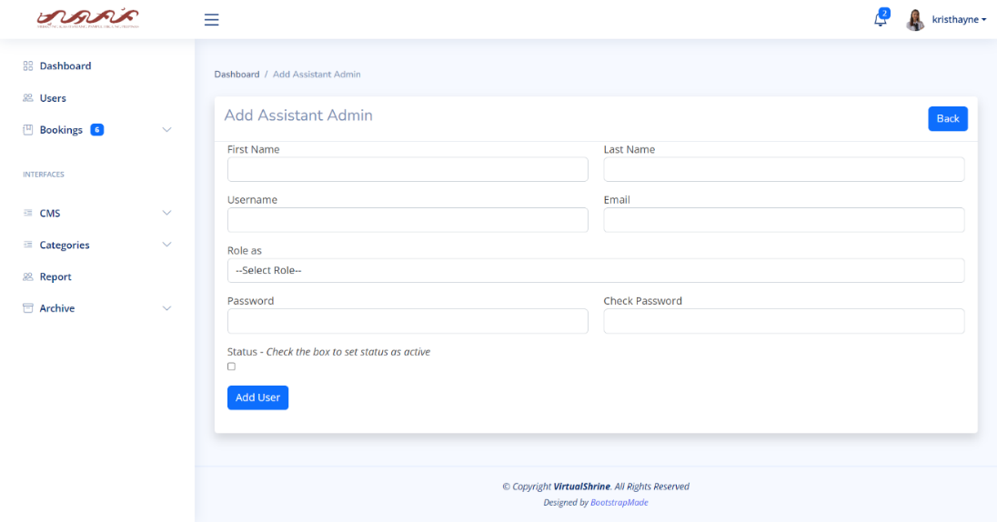

**Figure 67. Add new User**

Figure 67 displays the Add User Information form. This is the form where the Super Admin can add the information of the new admin.

**2.2 Accept and Reject Visitor Booking**

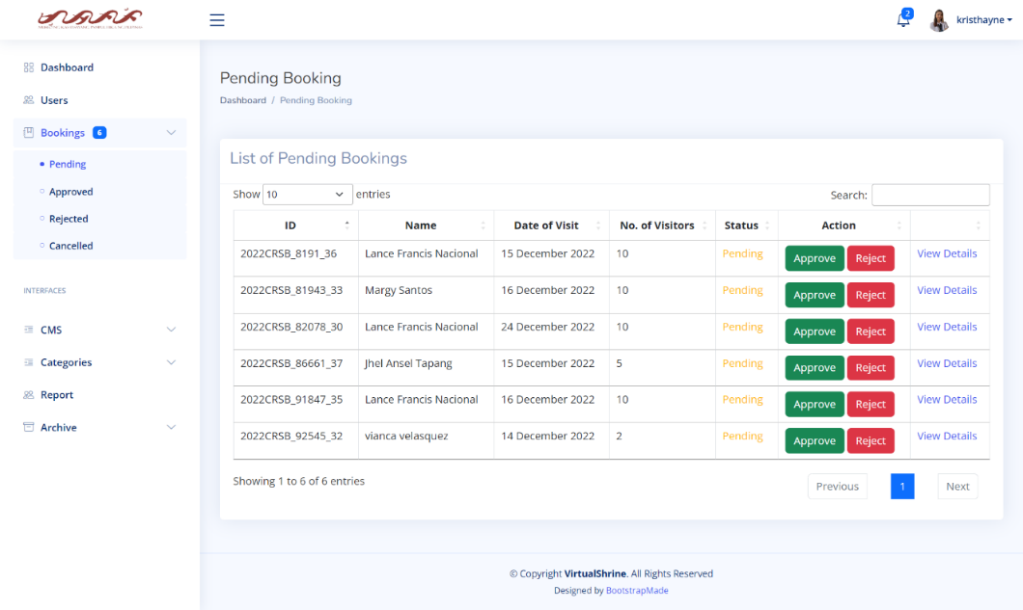

**Figure 68. View all Pending Booking**

In Figure 68, a table displays the pending bookings, including the Booking ID, Name of Visitor, Date of Visit, Number of Visitors, and status of the booking. For additional information, the admin can click “View Details”.

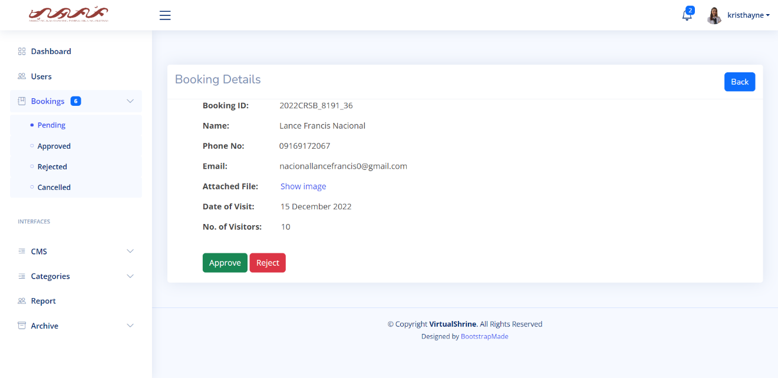

**Figure 69. View More booking details**

Figure 69 displays the page where the complete booking information is displayed. This page displays the Booking ID, Name, Phone No., Email, Attached File, Date of Visit, and Number of Visitors. The admin can also perform an action on this page either to approve or reject the booking.

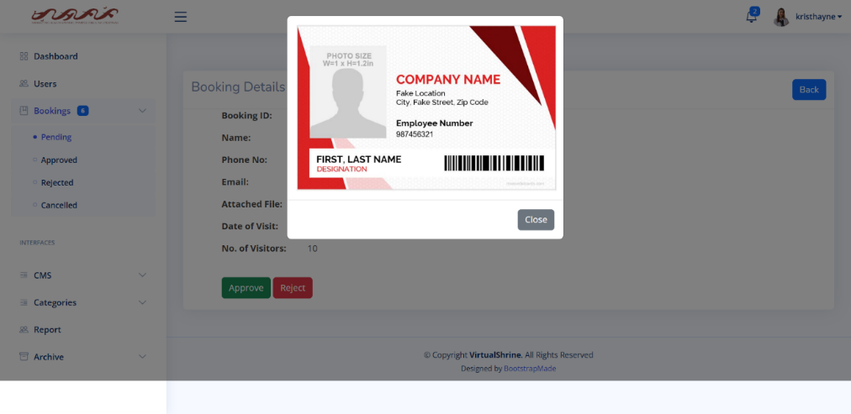

**Figure 70. View More booking details**

Once the admin clicks the "show image" button, Figure 70 displays the page response. This feature is used to allow admins to verify the legitimacy of the attached ID.

**2.3 Upload Website Content**

This module is the CMS of the Management System. This allows admins to upload and modify website contents.

**2.3.1 Collections**

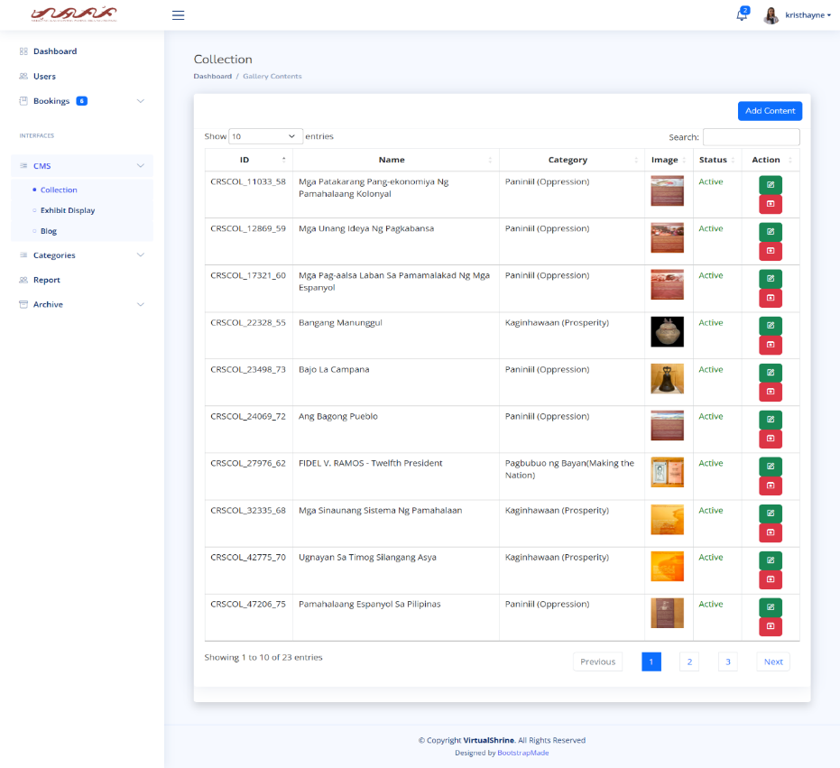

**Figure 71. Content Management System - Collections**

In Figure 71, the Collection CMS is shown. It includes a table that provides information about the collection, such as its ID, title, the gallery it belongs to, a preview image, and its status. There are also action buttons for editing and archiving.

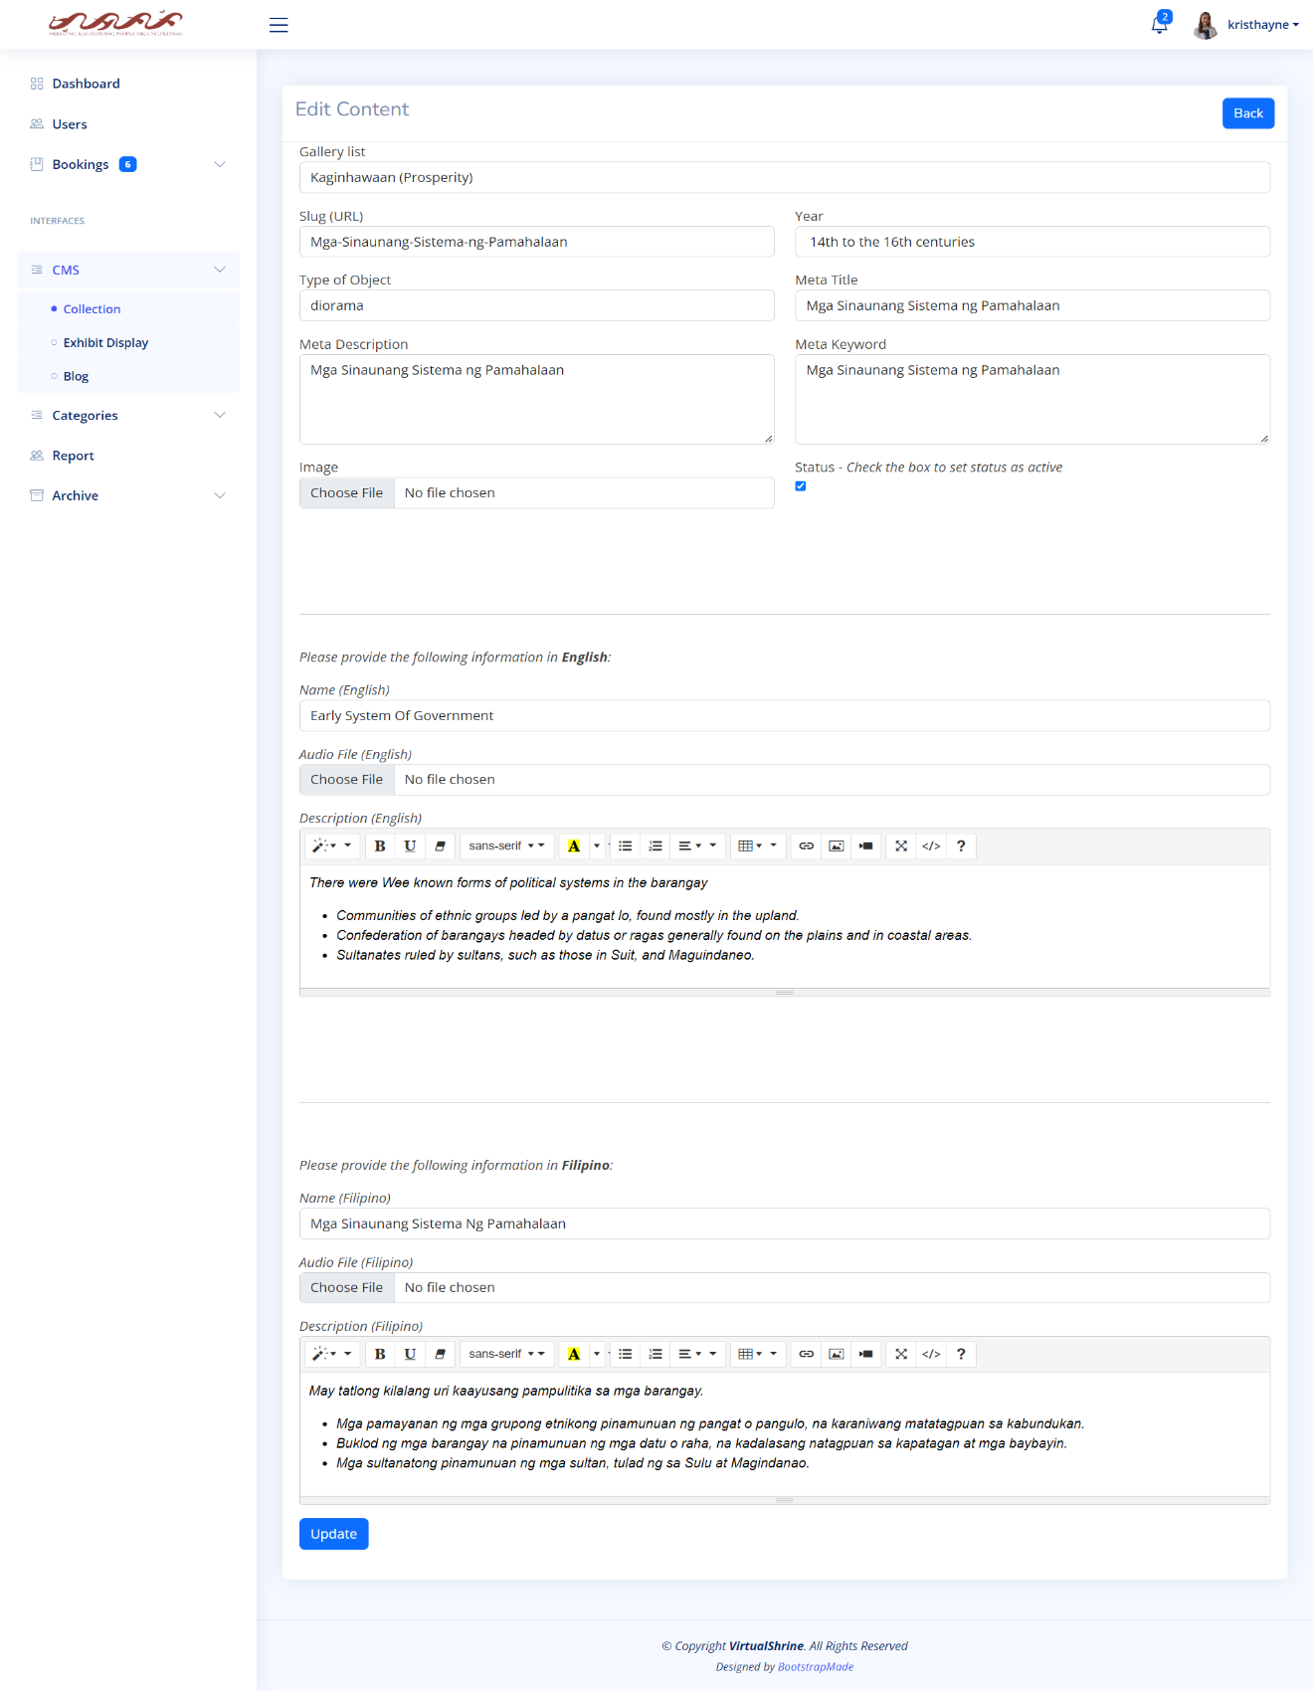

**Figure 72. Content Management System – Edit Collection Information**

As seen in Figure 72, the Edit Collection form gives admins the ability to edit the collection's information.

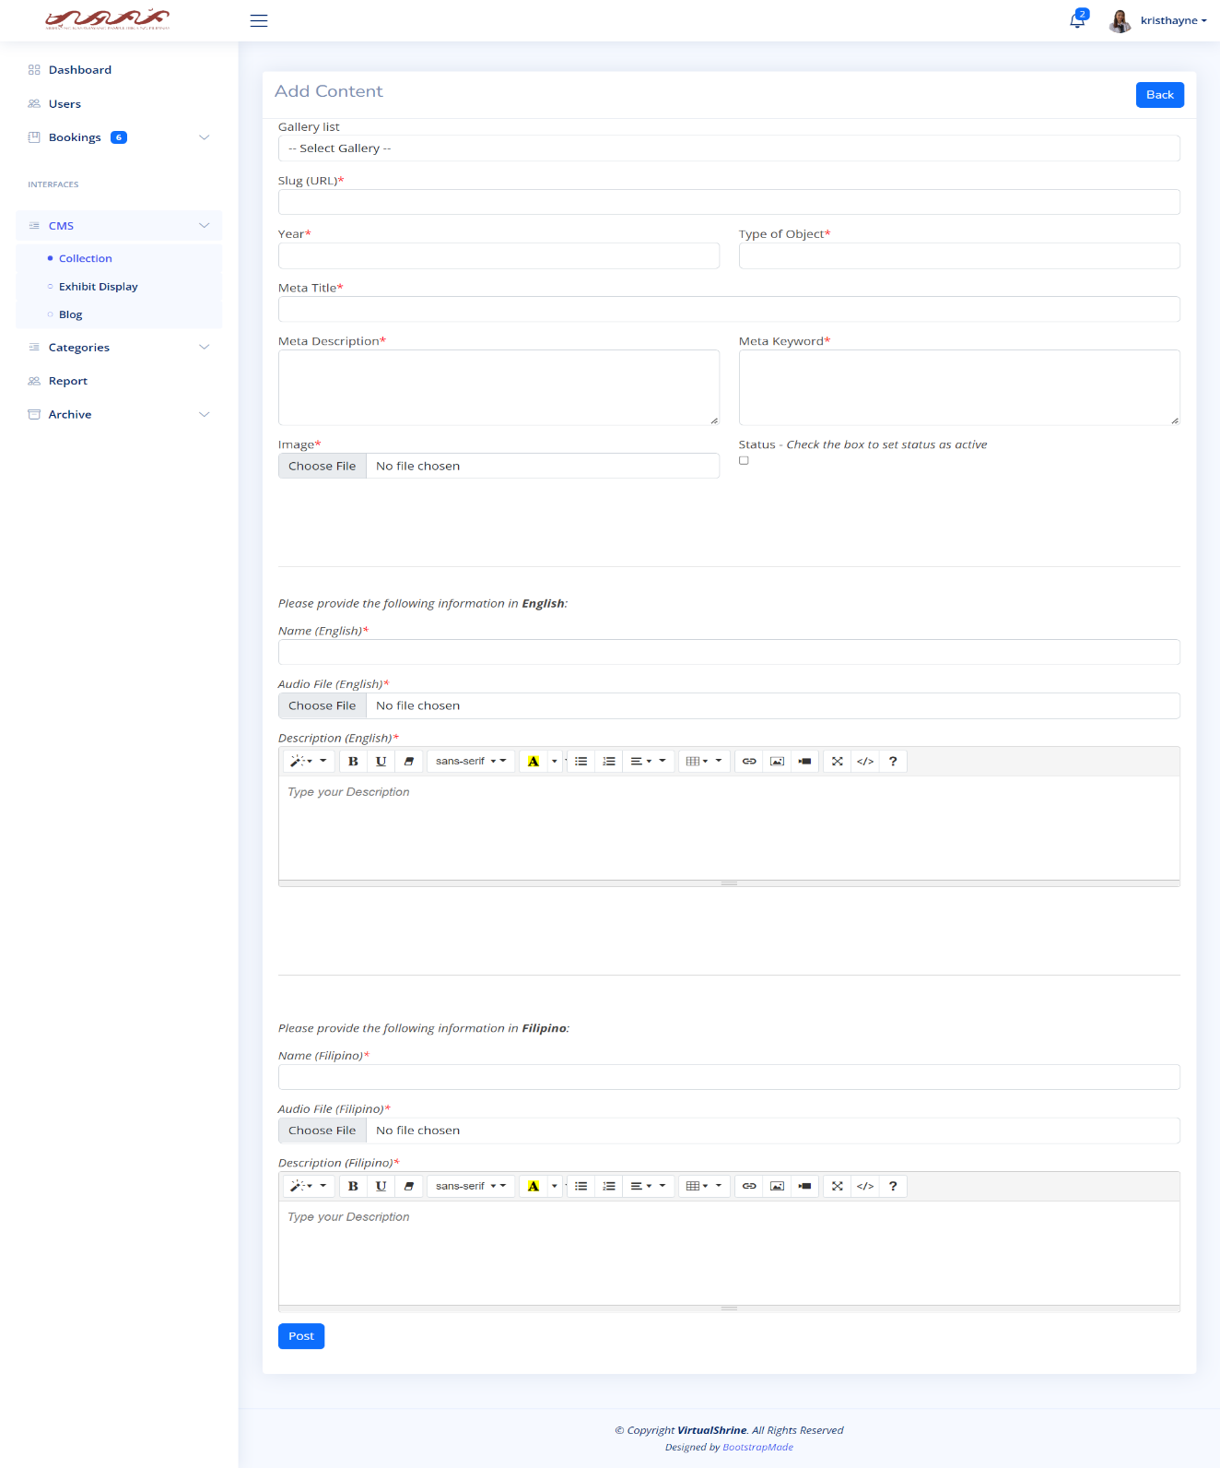

**Figure 73. Content Management System – Add new Collection**

In Figure 73, the Add new Collection form is shown. This is where the admin can add new collection that will be displayed on its respective gallery category on the website.

**2.3.2 Exhibits**

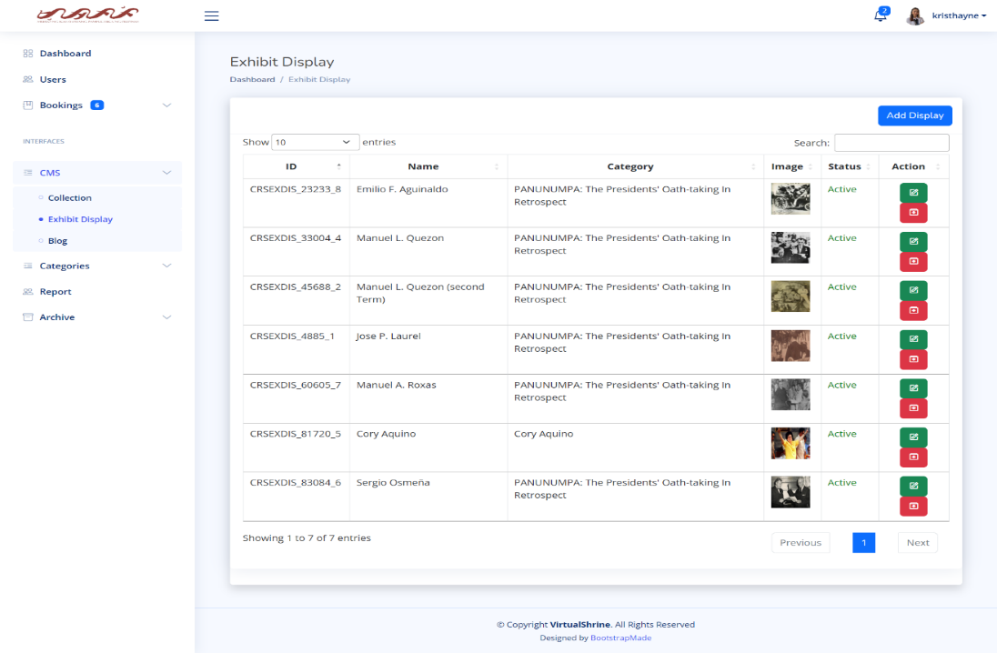

**Figure 74. Content Management System – Exhibit Display**

In Figure 74, the Exhibit Display CMS is shown. It includes a table that provides information about the Exhibit Display, such as its ID, Title or Name, the Exhibit it belongs to, a preview image, and its status. There are also action buttons for editing and archiving.

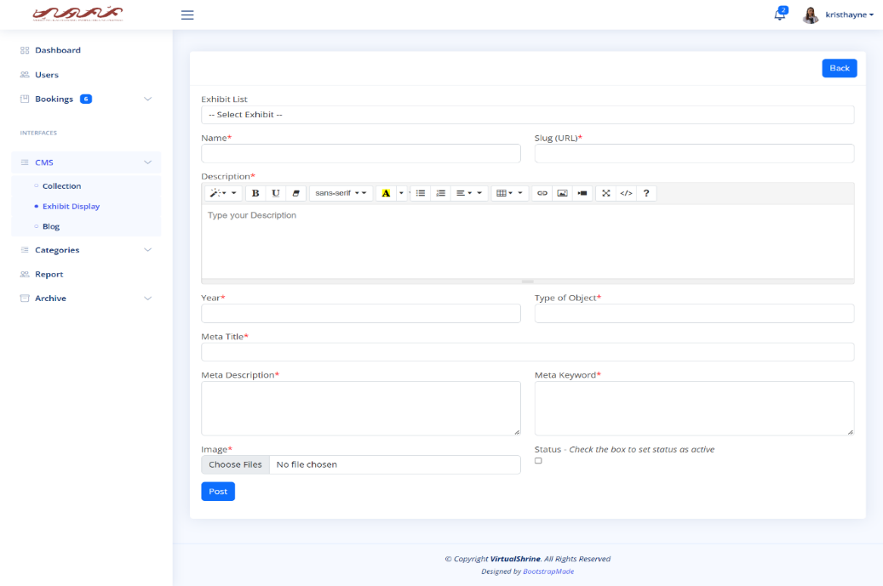

**Figure 75. Content Management System – Add new Exhibit Display**

In Figure 75, the Add new Exhibit Display form is shown. This is where the admin can add new Exhibit Display.

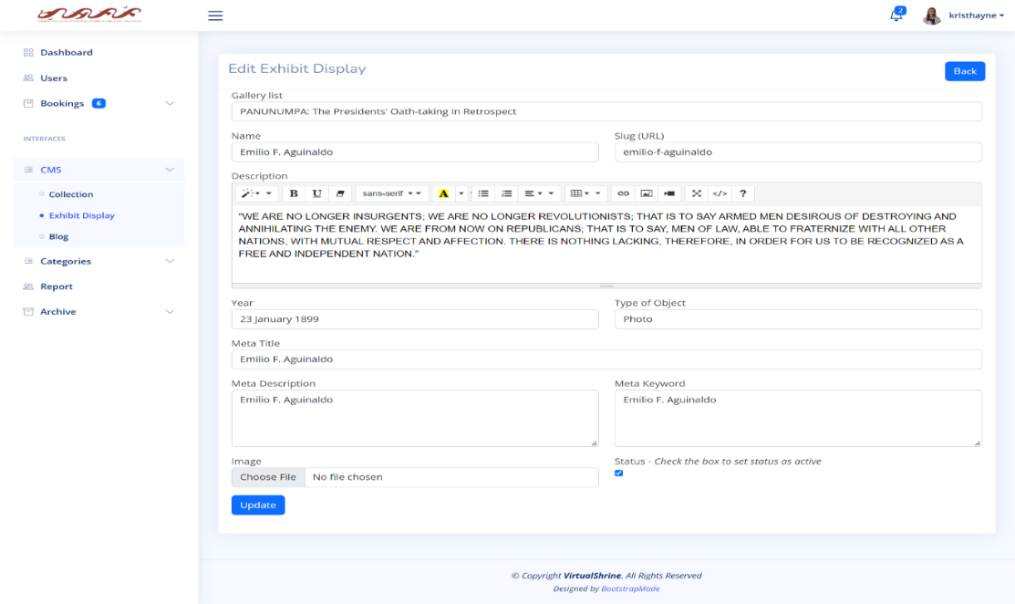

**Figure 76. Content Management System – Edit Exhibit Display**

As seen in Figure 76, the Edit Exhibit display form gives admins the ability to edit the Exhibit display information.

**2.3.3 Blogs**

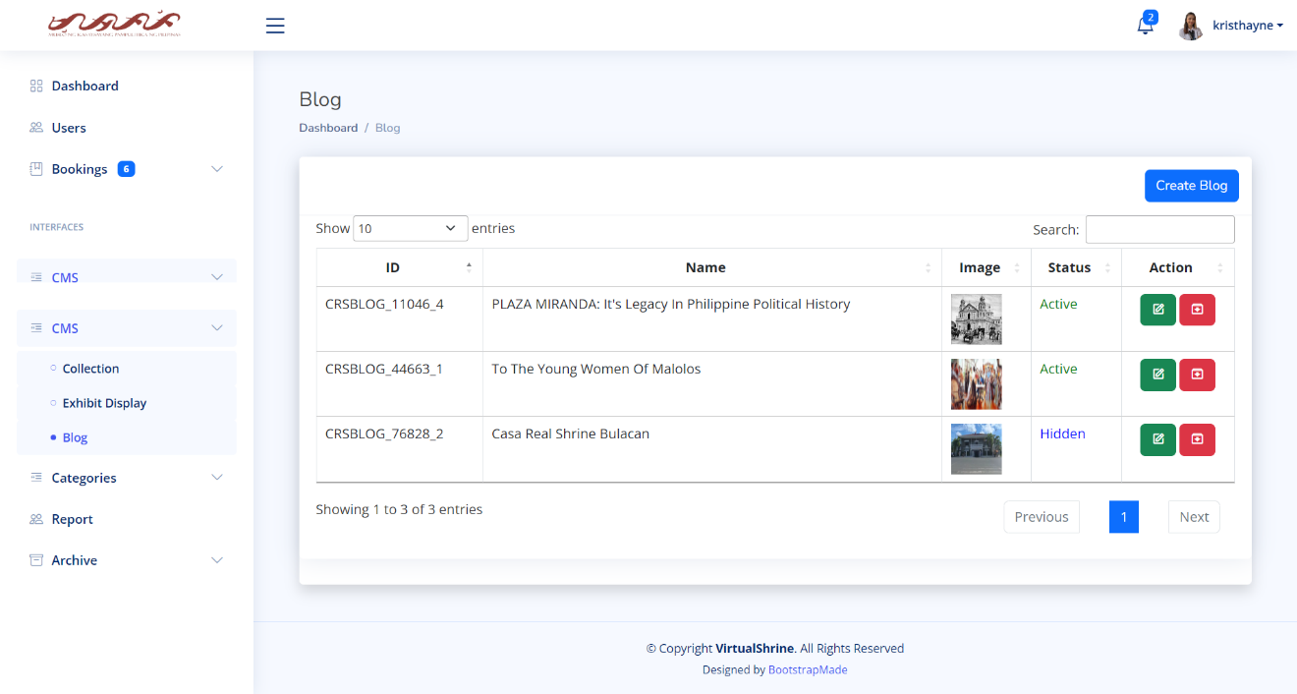

**Figure 77. Content Management System - Blog**

In Figure 77, the Blog CMS is shown. It includes a table that provides information about the Blog, such as its ID, Name, a preview image, and its status. There are also action buttons for editing and archiving.

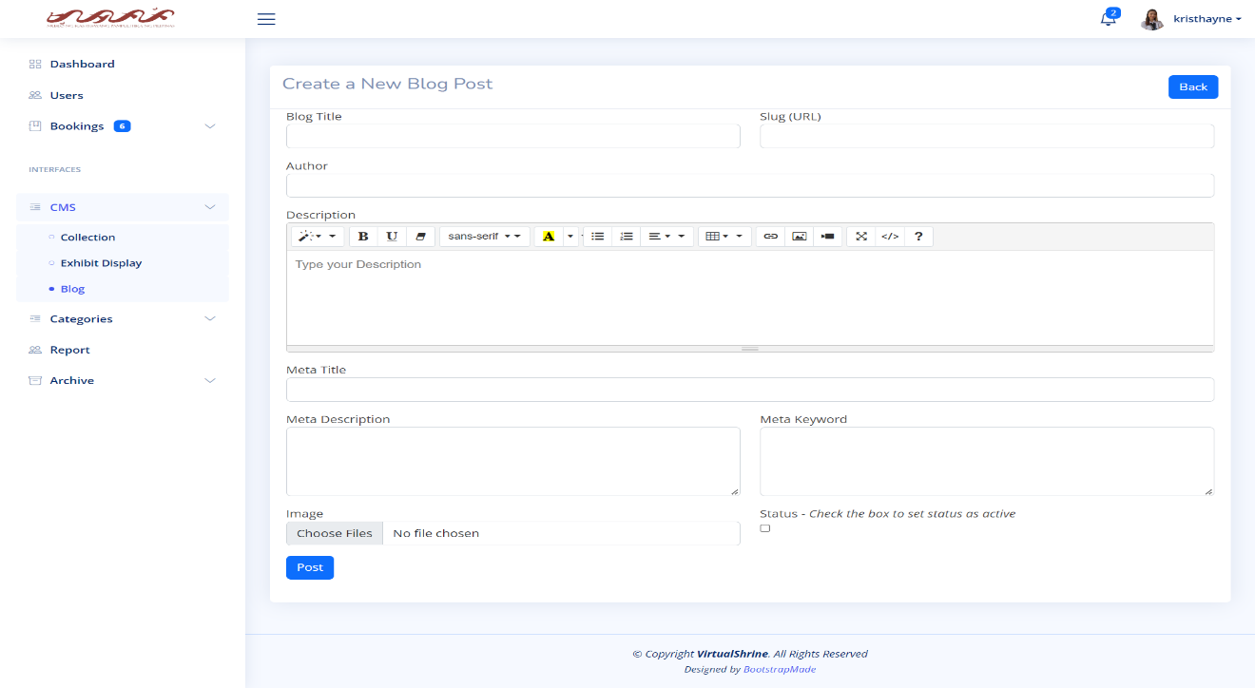

**Figure 78. Content Management System – Create a Blog Post**

In Figure 78, the Create a Blog form is shown. This is where the admin can add and upload new Blog posts.

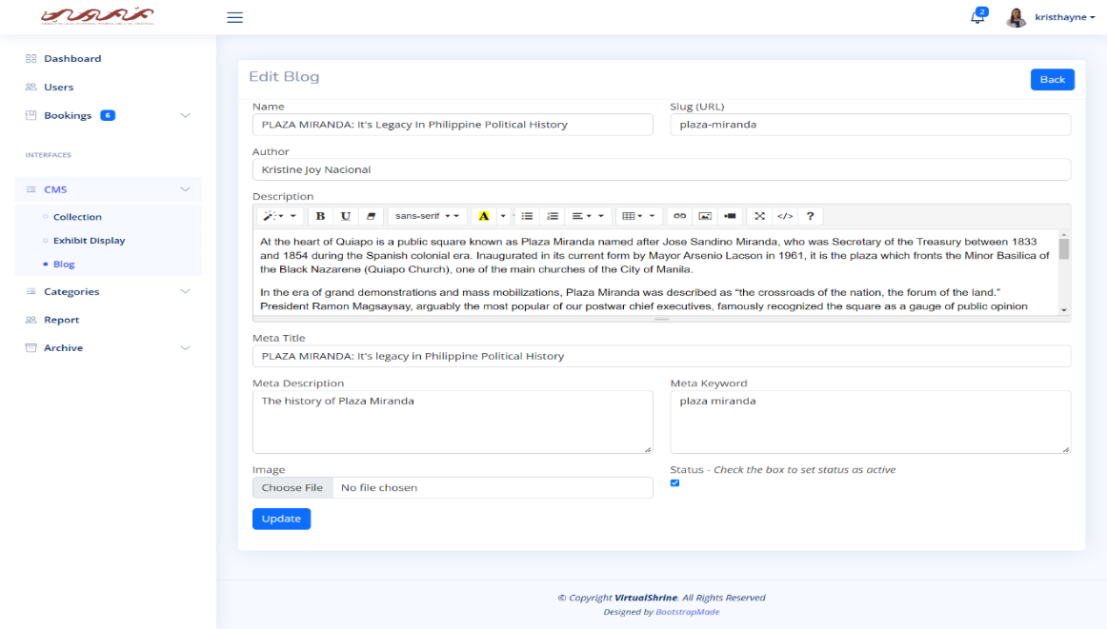

**Figure 79. Content Management System – Edit Blog**

As seen in Figure 79, the Edit Blog form gives admins the ability to edit the Blog information.

**2.4 Generate and Print Admin Activity Record**

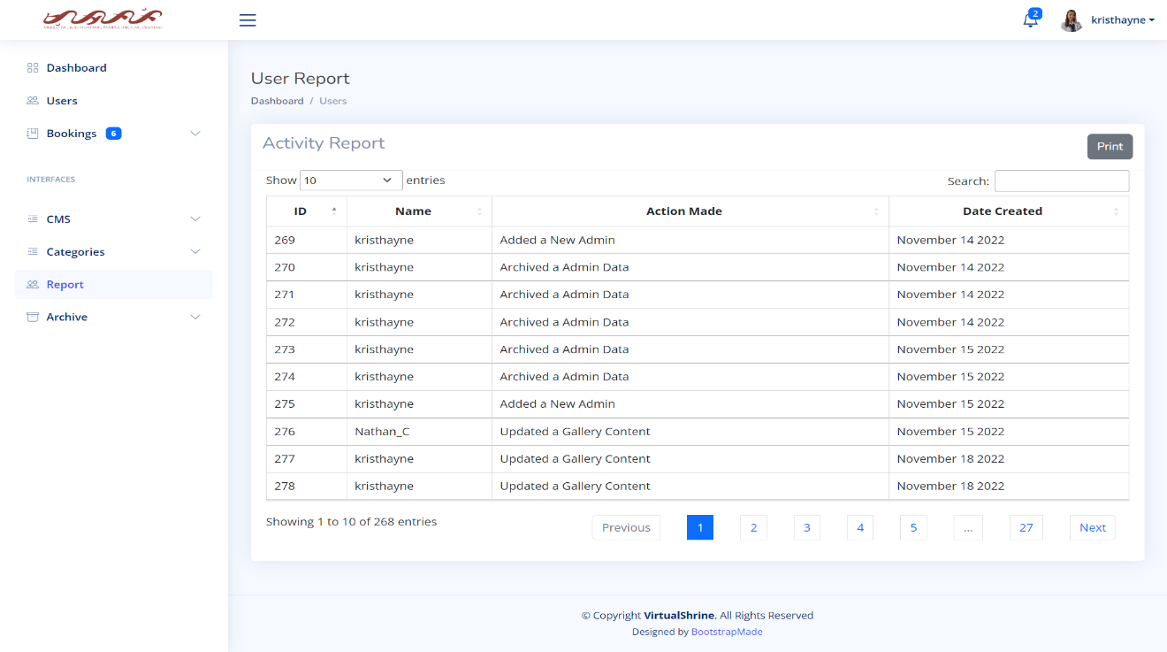

**Figure 80. Activity Report**

Figure 80 shows every activity like editing some of the website content or updating profile of the admin. It also includes the date when the data is change.

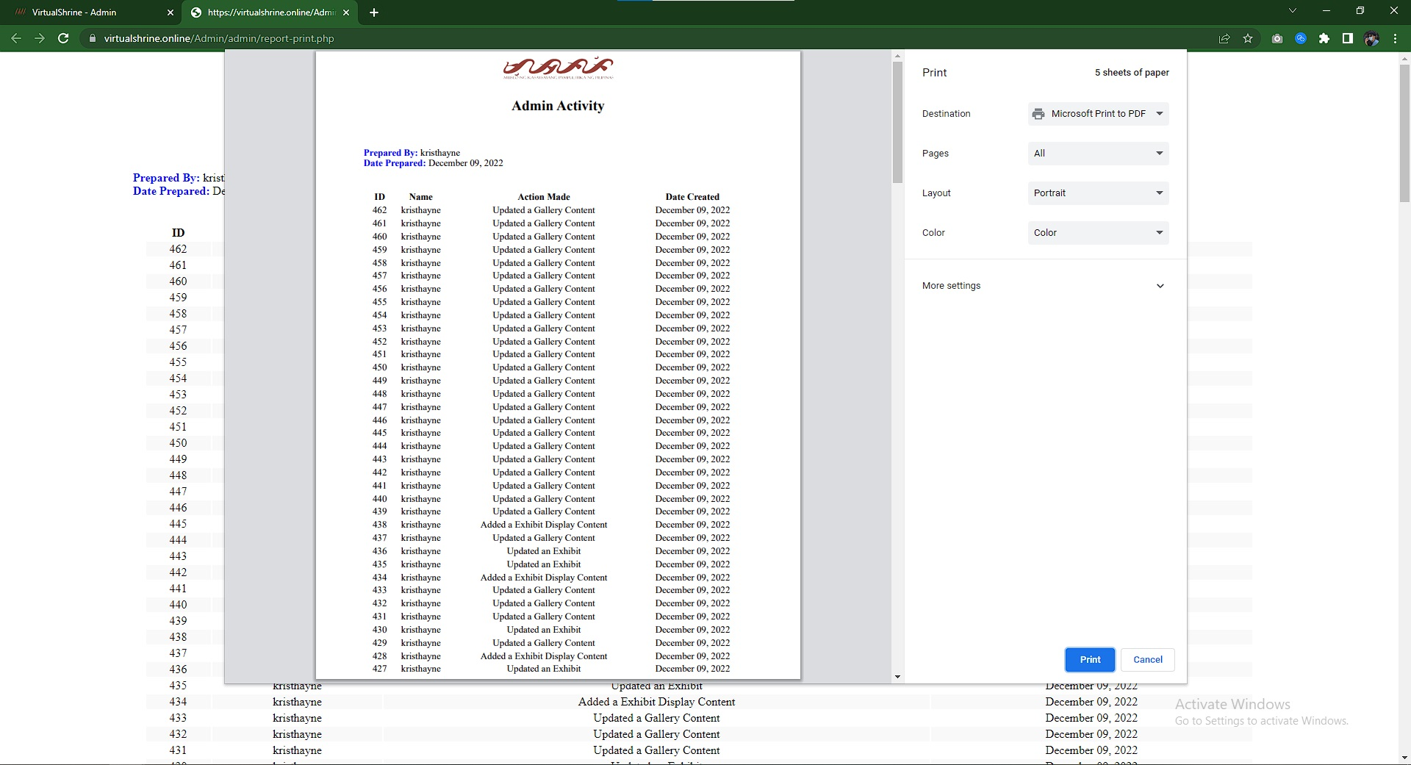

**Figure 81. Printing Report**

Figure 81 shows the printing report. This will help the admin to have a hard copy of the data when it needs to be submitted on the museum for the documentation.

* 1. **Booking Confirmation through email after reservation**



**Figure 82. Email from the Administration**

Figure 82 displays the confirmation of booking reservation. This confirmation email will automatically be sent to the email provided by the visitor during the booking process if the administrator approves their booking. The email includes the booking information, reminders, and the link for cancellation and rescheduling of booking.

**Part III. Software Quality Evaluation of the VirtualShrine: An Interactive Museum Website for Casa Real Shrine**

It is comprised of several tables that illustrate how well the VirtualShrine: An Interactive Museum Website performs. Table 3 shows the *Functional Suitability* criterion; Table 4 shows the *Performance Efficiency* criterion; Table 5 shows the *Usability* criterion; Table 6 shows the *Reliability* criterion; and Table 7 shows the *Portability* criterion. In addition, a table that presents the total number of respondents and a five-score Likert scale are also included. The developed application was assessed in terms of functional suitability, performance efficiency, usability, reliability, and portability using the ISO/IEC 25010:2011 or the Square - System and Software Quality Models.

**Table 6**

|  |  |  |
| --- | --- | --- |
| **Total Number of Respondents** | | |
| **Evaluators** | **Frequency** | **Percentage (%)** |
| IT Professionals | 5 | 11% |
| CICT Faculty | 5 | 11% |
| Casa Real Shrine Museum Staff | 3 | 7% |
| Student | 12 | 27% |
| Local Tourist | 10 | 22% |
| Foreign Tourist | 10 | 22% |
| **TOTAL** | **45** | **100%** |

The respondents of this study are five (5) IT Professionals that have proven extensive knowledge or working in the field of Information Technology, five (5) Faculty Members from the College of Information and Communications Technology, five (5) Local Tourist, five (5) Foreign Tourist and five (5) Casa Real Shrine Museum Staff.

**Table 7**

|  |  |  |
| --- | --- | --- |
| **5-Score Likert Scale** | | |
| **Scale** | **Range** | **Descriptive Interpretation** |
| 5 | 4.60-5.00 | Strongly Agree |
| 4 | 3.60-4.59 | Agree |
| 3 | 2.60-3.59 | Moderately Agree |
| 2 | 1.60-2.59 | Disagree |
| 1 | 0-1.59 | Strongly Disagree |

The evaluation procedure used a five-score scale which is 1 for Strongly Disagree, 2 for Disagree, 3 for Moderately Agree, 4 for Agree, and 5 for Strongly Agree. The fives-core rating with its frequencies was collected from 45 respondents and the computed mean.

**Table 8**

|  |  |  |  |  |  |  |  |  |
| --- | --- | --- | --- | --- | --- | --- | --- | --- |
| Frequency Distribution and Descriptive Measures in the Evaluation of the Developed Website in terms of Functional Suitability | | | | | | | | |
| ***No.*** | ***Characteristics*** | ***5*** | ***4*** | ***3*** | ***2*** | ***1*** | ***Mean*** | ***Descriptive Interpretation*** |
| **1** | ***Functional Completeness.*** The system functions according to its intended purpose. | **32** | **10** | **3** | **0** | **0** | **4.64** | Strongly Agree |
| **2** | ***Functional Correctness***. The system gives the exact output on each input per module. | **30** | **13** | **2** | **0** | **0** | **4.62** | Strongly Agree |
| **3** | ***Functional Appropriateness***. The system functions like any standard system entirely. | **32** | **10** | **3** | **0** | **0** | **4.64** | Strongly Agree |
|  | | **Weighted Mean** | | | | | **4.64** | **Strongly Agree** |

*4.60 - 5.00 Strongly Agree, 3.60 - 4.59 Agree, 2.60 - 3.59 Moderately Agree, 1.60 - 2.59 Disagree,0 - 1.59 Strongly Disagree*

Table 8. Show Under the functional suitability sub characteristics, the functional completeness has a total mean of 4.64, interpreted as Strongly Agree, proved the developed website is capable to attain specified user objectives. Functional correctness has a total mean of 4.62, interpreted as Strongly Agree and still has a high acceptance rating from the respondents. And lastly, functional appropriateness has a total mean of 4.64, interpreted as Strongly Agree proved the developed website has an efficient and effective way of accomplishing all the specified tasks. Based on all the computed mean 4.64 is the final interpretation of the respondents it means that they are strongly agree that the website is with the functionality of the developed web portal.

**Table 9**

|  |  |  |  |  |  |  |  |  |
| --- | --- | --- | --- | --- | --- | --- | --- | --- |
| Frequency Distribution and Descriptive Measures in the Evaluation of the Developed Website in terms of Performance Efficiency | | | | | | | | |
| ***No.*** | ***Characteristics*** | ***5*** | ***4*** | ***3*** | ***2*** | ***1*** | ***Mean*** | ***Descriptive Interpretation*** |
| **1** | ***Time-Behavior.*** The system's response and processing times, as well as its throughput rates, carry out its intended tasks and adhere to the specifications. | **34** | **7** | **3** | **1** | **0** | **4.64** | Strongly Agree |
| **2** | ***Resource Utilization.*** The amount and kind of resources used by the system meet the criteria. | **31** | **11** | **3** | **0** | **0** | **4.62** | Strongly Agree |
| **3** | ***Capacity.*** The system manages time efficiently and effectively. | **32** | **11** | **2** | **0** | **0** | **4.67** | Strongly Agree |
| **4** | ***System accuracy.*** The system accurately presents the output at the maximum level. | **33** | **9** | **3** | **0** | **0** | **4.67** | Strongly Agree |
|  | | **Weighted Mean** | | | | | **4.65** | **Strongly Agree** |

*4.60 - 5.00 Strongly Agree, 3.60 - 4.59 Agree, 2.60 - 3.59 Moderately Agree, 1.60 - 2.59 Disagree,0 - 1.59 Strongly Disagree*

Table 9. Based on the information provided, it appears that the VirtualShrine website has performed well in terms of its time behavior, resource utilization, capacity, and system accuracy. The respondents strongly agreed with the performance efficiency of the website, as indicated by the weighted mean of 4.65. This suggests that the website was able to meet the expected results in a short amount of time and uses a small proportion of resources when in use. Overall, it seems that the VirtualShrine website is efficient in its performance.

**Table 10**

|  |  |  |  |  |  |  |  |  |
| --- | --- | --- | --- | --- | --- | --- | --- | --- |
| Frequency Distribution and Descriptive Measures in the Evaluation of the Developed Website in terms of Compatibility | | | | | | | | |
| ***No.*** | ***Characteristics*** | ***5*** | ***4*** | ***3*** | ***2*** | ***1*** | ***Mean*** | ***Descriptive Interpretation*** |
| **1** | ***Co-Existence.*** The system can efficiently perform its required functions while sharing a familiar environment and resources with other systems, with no negative influence on any other method. | **34** | **9** | **1** | **1** | **0** | **4.69** | Strongly Agree |
| **2** | ***Interoperability.*** The system can exchange information and utilize data that has been exchanged between two or more platforms. | **30** | **12** | **3** | **0** | **0** | **4.6** | Agree |
| **3** | ***Flexibility.*** The system can be accessed on both phone and computer browsers. | **35** | **9** | **1** | **0** | **0** | **4.76** | Strongly Agree |
|  | | **Weighted Mean** | | | | | **4.69** | **Strongly Agree** |

*4.60 - 5.00 Strongly Agree, 3.60 - 4.59 Agree, 2.60 - 3.59 Moderately Agree, 1.60 - 2.59 Disagree,0 - 1.59 Strongly Disagree*

Table 10. Shows the items used in determining the compatibility of the developed website. Which is categorized by Co-Existence, Interoperability and Flexibility. The Compatibility have a total means of 4.96 which interpreted as Strongly Agree. This shows that the website Virtual Shrine is having complete features when it comes to compatibility.

**Table 11**

|  |  |  |  |  |  |  |  |  |
| --- | --- | --- | --- | --- | --- | --- | --- | --- |
| Frequency Distribution and Descriptive Measures in the Evaluation of the Developed Website in terms of Reliability | | | | | | | | |
| ***No.*** | ***Characteristics*** | ***5*** | ***4*** | ***3*** | ***2*** | ***1*** | ***Mean*** | ***Descriptive Interpretation*** |
| **1** | ***Maturity***. Under normal conditions, the system meets the requirements for reliability. | **33** | **10** | **2** | **0** | **0** | **4.69** | Strongly Agree |
| **2** | ***Availability.*** The system is operational and accessible when required for use. | **35** | **7** | **3** | **0** | **0** | **4.71** | Strongly Agree |
| **3** | ***Fault Tolerance.*** Despite the presence of hardware or software faults, the system or its components function as planned. | **30** | **14** | **1** | **0** | **0** | **4.64** | Strongly Agree |
| **4** | ***Recoverability.*** In an interruption or failure, the system can immediately recover the affected data and restore the system to its desired state. | **33** | **9** | **3** | **0** | **0** | **4.67** | Strongly Agree |
|  | | **Weighted Mean** | | | | | **4.68** | **Strongly Agree** |

*4.60 - 5.00 Strongly Agree, 3.60 - 4.59 Agree, 2.60 - 3.59 Moderately Agree, 1.60 - 2.59 Disagree,0 - 1.59 Strongly Disagree*

Table 11. Shows the items used to determining the reliability of the developed website by means of Maturity, Availability, Fault Tolerance, and Recoverability. The total mean of reliability that comes from the respondents is 4.68 which interpreted as Strongly Agree. This demonstrates that the created web portal is trustworthy when used normally and is accessible and fully functional when needed.

**Table 12**

|  |  |  |  |  |  |  |  |  |
| --- | --- | --- | --- | --- | --- | --- | --- | --- |
| Frequency Distribution and Descriptive Measures in the Evaluation of the Developed Website in terms of Security | | | | | | | | |
| ***No.*** | ***Characteristics*** | ***5*** | ***4*** | ***3*** | ***2*** | ***1*** | ***Mean*** | ***Descriptive Interpretation*** |
| **1** | ***Confidentiality.*** The system guarantees that the data is only available to those granted access. | **38** | **6** | **1** | **0** | **0** | **4.82** | Strongly Agree |
| **2** | ***Accountability.*** The actions of an entity can be traced uniquely by the system to the entity. | **37** | **7** | **1** | **0** | **0** | **4.8** | Strongly Agree |
| **3** | **Integrity**. The system prevents unauthorized access to, or modification of data. | **33** | **11** | **1** | **0** | **0** | **4.71** | Strongly Agree |
|  | | **Weighted Mean** | | | | | **4.78** | **Strongly Agree** |

*4.60 - 5.00 Strongly Agree, 3.60 - 4.59 Agree, 2.60 - 3.59 Moderately Agree, 1.60 - 2.59 Disagree,0 - 1.59 Strongly Disagree*

Table 12. Shows the items used in determining the security of the developed website. Which is categorized by Confidentiality, Accountability, and Integrity. The Security have a total mean of 4.78 that comes from the respondents which interpreted as Strongly Agree. The system makes sure the data are secure, prohibits unauthorized users from accessing and changing the data, and saves auditable logs that demonstrate each activity was made.

**Table 13**

|  |  |  |  |  |  |  |  |  |
| --- | --- | --- | --- | --- | --- | --- | --- | --- |
| Frequency Distribution and Descriptive Measures in the Evaluation of the Developed Website in terms of Maintainability | | | | | | | | |
| ***No.*** | ***Characteristics*** | ***5*** | ***4*** | ***3*** | ***2*** | ***1*** | ***Mean*** | ***Descriptive Interpretation*** |
| **1** | ***Modularity.*** Because the system is made up of distinct parts, altering one has little to no impact on the others. | **39** | **6** | **0** | **0** | **0** | **4.87** | Strongly Agree |
| **2** | ***Modifiability***. The system allows updating different user records through level of security. | **35** | **9** | **1** | **0** | **0** | **4.76** | Strongly Agree |
| **3** | ***Testability***. It is clear that the application is effective and efficient. For the product, test criteria can be set, and tests can be run to see if the criteria have been met. | **35** | **9** | **1** | **0** | **0** | **4.76** | Strongly Agree |
| **4** | ***Analyzability.*** The system works well and efficiently. One can evaluate the effects of a planned modification to a system or product on one or more of its components. | **35** | **10** | **0** | **0** | **0** | **4.78** | Strongly Agree |
|  | | **Weighted Mean** | | | | | **4.79** | **Strongly Agree** |

*4.60 - 5.00 Strongly Agree, 3.60 - 4.59 Agree, 2.60 - 3.59 Moderately Agree, 1.60 - 2.59 Disagree,0 - 1.59 Strongly Disagree*

Table 13 shows the items used in determining the maintainability of the developed system, which is categorized by Modularity, Modifiability, Testability, and Analyzability. The total computed mean for the maintainability is 4.79 which interpreted as Strongly Agree. It demonstrates the system's adaptability to various hardware, software, and other operational or usage scenarios. Mobile devices like smartphones, tablets, and PCs can all access the designed system online.

**Table 14**

|  |  |  |  |  |  |  |  |  |
| --- | --- | --- | --- | --- | --- | --- | --- | --- |
| Frequency Distribution and Descriptive Measures in the Evaluation of the Developed Website in terms of Portability | | | | | | | | |
| ***No.*** | ***Characteristics*** | ***5*** | ***4*** | ***3*** | ***2*** | ***1*** | ***Mean*** | ***Descriptive Interpretation*** |
| **1** | ***Adaptability.*** The system can effectively and efficiently be adapted for different evolving hardware, software, or other operational or usage environments. | **38** | **7** | **0** | **0** | **0** | **4.84** | Strongly Agree |
|  | | **Weighted Mean** | | | | | **4.84** | **Strongly Agree** |

*4.60 - 5.00 Strongly Agree, 3.60 - 4.59 Agree, 2.60 - 3.59 Moderately Agree, 1.60 - 2.59 Disagree,0 - 1.59 Strongly Disagree*

Table 14 shows the item used in determining the portability of the developed system, which is categorized by Adaptability. Out of 45 respondents 38 is strongly agree and 7 is agree for the adaptability of the website. The portability have a total mean of 4.84 which interpreted as Strongly Agree. This means that the respondents is strongly agree with portability of the website Virtual Shrine.

**Table 15**

|  |  |  |
| --- | --- | --- |
| **Software Criteria** | **Computed Mean** | **Descriptive Interpretation** |
| **1. Functional Suitability** | **4.64** | **Strongly Agree** |
| **2. Performance Efficiency** | **4.65** | **Strongly Agree** |
| **3. Compatibility** | **4.69** | **Strongly Agree** |
| **4. Reliability** | **4.68** | **Strongly Agree** |
| **5. Security** | **4.78** | **Strongly Agree** |
| **6. Maintainability** | **4.79** | **Strongly Agree** |
| **7. Portability** | **4.84** | **Strongly Agree** |
| **Overall Mean** | **4.72** | **Strongly Agree** |

Functional Suitability registered a computed mean of 4.64 with a descriptive interpretation as “Strongly Agree”. Performance Efficiency on the other hand acquired 4.65 which is also interpreted as “Strongly Agree”. Compatibility registered a computed mean of 4.69 with a descriptive interpretation as “Strongly Agree”. Reliability registered a computed mean 4.68 with a descriptive interpretation as “Strongly Agree”. Security registered a computed mean 4.78 with a descriptive interpretation as “Strongly Agree”. Maintainability registered a computed mean 4.79 with a descriptive interpretation as “Strongly Agree”. Portability acquired 4.84 which garnered the highest mean among the other criteria.